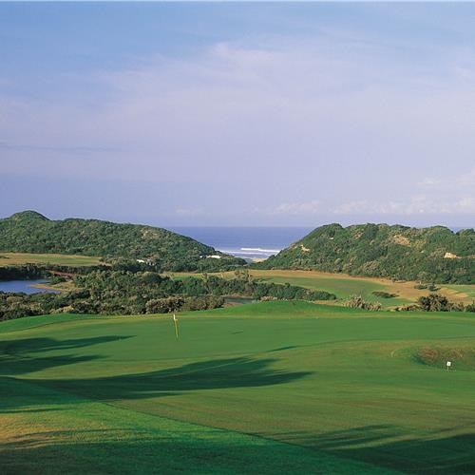

**Dear Border Nomad.**

You are cordially invited to compete for Club honour and pride, against our Eastern Cape counterparts in the annual Rough Rider and Frontier Trophy events taking place on 16th and 17th of June 2018 respectively.

**ROUGH RIDER CUP - SATURDAY 16th June 2018**

This will be held again at the Fish River Sun Golf Resort over 36 x holes. There will be a limited field allowed of players for the competition itself although more players can be accommodated. Please get your entries in as soon as possible

Costs : as per the breakdown below

Dress Code : respectable golf attire. No prize giving on Saturday.

1st Tee Off : 07:30

Format : Foursomes

(1 x point for a win / 0.5 points for a draw)

2nd Tee Off : 11:30

Format : Betterball Stableford

(1 x point for a win / 0.5 points for a draw)

Golf and Golf Carts : R 500.00 per player and shared cart for 36 holes.

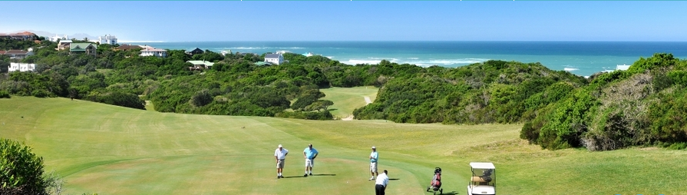

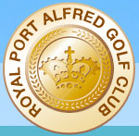

**FRONTIER TROPHY - SUNDAY 17TH June 2018**

To be played between Border Nomads and Eastern Cape Nomads on the ever challenging but picturesque Royal Port Alfred Golf Course.

Cost : R220.00 per Player

Tee Off : 09:00 onwards

Dress Code : Nomads golf attire on course & number 1s for prize giving.

Format : Singles Medal Stableford played between pairs

Player 1 vs. Player 3/Player 2 vs. Player 4

(1 x point for a win / 0.5 points for a draw)

Golf Cart : R250.00 per cart (book with Club – only 25No. available, on first come basis)

**Please note that this is not a monthly game so please advise playing partners names where necessary. Also keep in mind that you are not automatically entered into the draw for the above games.**

**____________________________________________________________________________**

**ENTRY FORM**

Please submit your Entry Form to reach **Basil Booysen (JVC)** by no later than **Wednesday 6th June 2018**.

Basil Booysen : [basil.booysen@za.nestle.com](mailto:basil.booysen@za.nestle.com)

Fax : 043 – 7037905

Email : basil.booysen@za.nestle.com

Cell 082 536 1048

**Player’s Name**  : ____­­­­­­­­­­­­­­­­­­­­­­­­­­­­­­­­­­­­______________________________________________

**16th June**  : Fish River Sun Golf Club

Rough Ryder Entry : Yes/No

Golf Cart : Inclusive

**17th June**  : Royal Port Alfred Golf Club

Frontier Trophy Entry : Yes/No

Golf Cart : Self booking with Royal Port Alfred Golf Club

**Basil Booysen**

*Junior Vice-Captain* (Border Nomads)

Cell: 082 536 1048

Email: